Statement of Work (SOW)

for

**Learning Management Solution (LIR)**

**&**

**SoP Learning App. with Gamification (DIR)**

Submitted by: **BJS INFOTECH**

Submitted to: **Vedanta Limited**

Contact : **Tanmay Mishra**

Director & CEO

Phone : 9764306366

Email : tanmay@bjs-smactsolutions.in

Website : www.bjs-smactsolutions.in

**Date: June 15, 2018**

Table of Contents

Section 1 Objective of the Engagement 3

Section 2 Scope & Roadmap of the Engagement 5

Section 3 Key Assumptions 8

Section 4 Program Governance Structure 9

Section 5 Expectation from Vedanta’s Team 10

Section 6 Risks 11

Section 7 Professional fees 12

1. Objective of the Engagement

BJS is pleased to submit a detailed Statement of Work (SoW) for implementation of ‘**Learning Management Solution (LIR)**’ and ‘**SoP Learning App. with Gamification (DIR)**’ of Vedanta. During the discussion at proposal stage, we understand the primary of objectives behind the implementation are as follows

* **Training Content should be closer to activities one will perform at Plant Site** with inclusion of images, videos, animations & real life scenarios
* **Enabling Learners to understand SoPs and various exception scenarios associated with**
* Content can be changed with **simple modification of configurations**

We believe implementation of LIR & DIR Application will benefit Vedanta in providing ‘**Effective Training**’ & ‘**Total Cost of Ownership of Platform**’. In addition to above benefits, it will also help in creating ‘**One-Stop Shop**’ for all training needs by creating it as ‘**Vedanta Virtual University**’ with courses from Engineering, Management Institutes & Consulting firms, IT Services firms and other entities of Vedanta Group. Additionally, it will also help in creating ‘**Knowledge Base**’ in the Organization with ideas from various experienced people.

**LIR Application Platform** will enable ‘Learning at Self-pace, with Group discussions’ and ‘Creation of Knowledge Base’ with various interactions as shown below

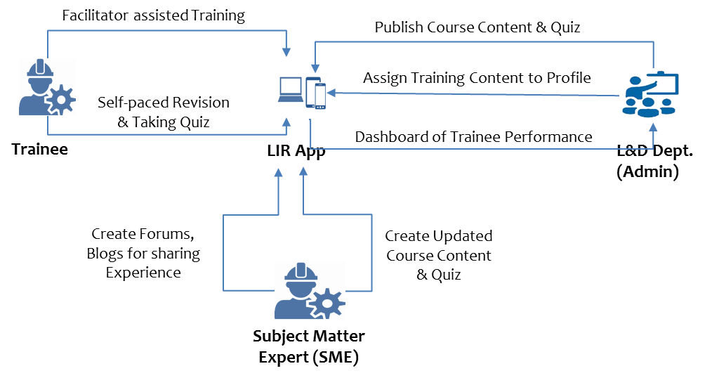

Figure 1: LIR Platform

DIR Application Platform will enable ‘Faster, Just-in-Time Learning of SoPs’ with various interactions as shown below

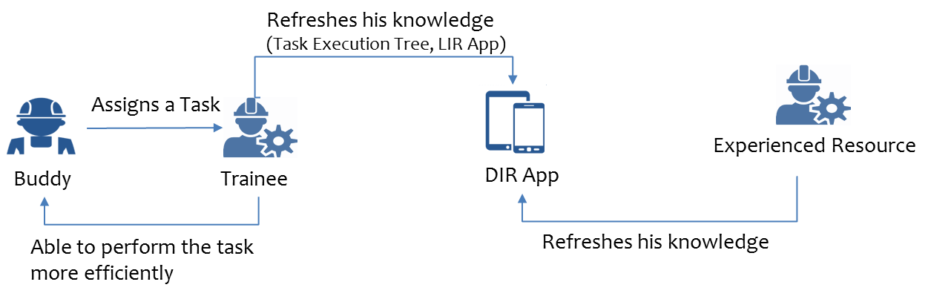

Figure 2: LIR Platform

1. Scope & Roadmap of the Engagement

This section outlines the scope of the engagement in detail for both ‘**Learning Management Solution (LIR)**’ and ‘**SoP Learning App. with Gamification (DIR)**’. BJS will present the complete Project Plan for the Engagement at the kick-off meeting to further elaborate the scope presented below.

* 1. Location

The primary location of the Engagement will be at Vedanta’s Jharsuguda (Odisha) Office.

* 1. Roadmap of the Engagement

Diagram below depicts BJS’s Roadmap for implementation of LIR Application for all 5 sub-processes of ‘Potline Operation’ and DIR Application for ‘Anode Change’ sub-process.

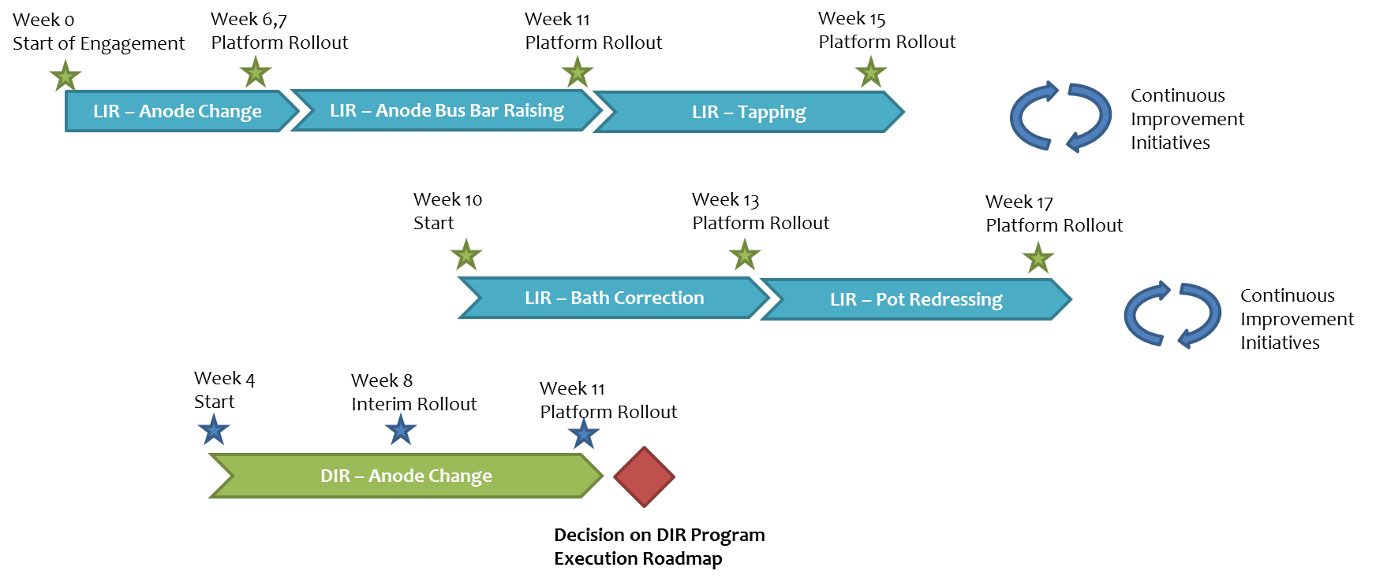

Figure 3: Implementation Roadmap

* 1. Milestone 1 : LIR Application for ‘Anode Change’ Sub-Process

As part of this Milestone, BJS will rollout ‘Anode Change’ sub-process training module along with key features of the Platform as mentioned below across all 6 Potline Control Rooms and L&D Training Center.

xx

**Deliverables**

1. LIR Application with following features
   1. Intuitive and interactive learning process with captivating animations
   2. Quiz at appropriate intervals for sanity check on the learning
   3. Insights and analytics indicating the efficacy of the process
   4. SSO / AD authentication and authorisation for various roles e.g LMS admin , LMS moderator, LMS proctor , LMS user
2. Installed version of Platform across all 6 Potline Control Rooms (Desktops) and L&D Training Center (Server)
3. Configure Desktops so that other desktops at vicinity can access the desktop
4. Scheduling batch jobs
5. User Manual for Administrators, Contributors & Users
   1. Milestone 2 : LIR Application for ‘Anode Busbar Raising’ Sub-Process

As part of this Milestone, BJS will rollout ‘Anode Busbar Raising’ sub-process training module along with key features of the Platform as mentioned below across all 6 Potline Control Rooms and L&D Training Center.

xx

**Deliverables**

1. LIR Application with additional features
   1. Management Dashboard (xx)
   2. Reward for Contributors (SME, Trainee)
   3. Automation of Workflow to upload Content & Questions
2. Updated User Manual for Administrators, Contributors & Users
3. Xx
   1. Milestone 2 : DIR Application for ‘Anode Change’ Sub-Process

DIR (Do It Right) is a solution of BJS innovations program for making LMS offering more outcome driven and aligned to the organization’s objective of having a sustainable and outcome driven solution to the ambitious digital based learning program of Vedanta’s LMS team . It basically ensures that the trainee has practically understood each and every aspect of the procedures thus referred to as SOPs both normal and exceptions and normalizations techniques to ensure seamless resumption of flow

**Deliverables**

1. User would have provision to create a nuclear chain reaction type of visual model mimicking a tree traversal view
2. Each node of the view would have processes , tasks and sub – tasks and their dependencies and would navigate from initiation to closure
3. A gamification approach to complete the process flow where a correct selection would increase your score and incorrect one would reduce it
4. Successive increase in complexity levels by adding exceptions or anomaly flows where advanced level of process knowledge is required to take judgements in critical cases and provide normalization techniques thereof
   1. Milestone 3 : LIR Application for ‘Bath Correction’ Sub-Process

xx

**Deliverables**

Xx

1. Updated User Manual for Administrators, Contributors & Users
2. xx
   1. Milestone 4 : LIR Application for ‘Tapping’ Sub-Process

xx

**Deliverables**

Xx

1. Updated User Manual for Administrators, Contributors & Users
2. xx
   1. Milestone 5 : LIR Application for ‘Pot Redressing’ Sub-Process

xx

**Deliverables**

Xx

1. Updated User Manual for Administrators, Contributors & Users
2. xx
   1. Out-Of-Scope:

The following activities are considered to be out-of-scope:

1. Content related to sub-processes (Text, Audio, Video) which will be shown in LIR Application
2. SoP with Exception Scenarios and their consequences on which DIR Application to be developed
3. xx

1. Key Assumptions

* Documentations are up to date and available for all applications. Customer will provide access to the systems and documentation at the start of the project
* Customer will ensure availability of its personnel as requested by BJS

1. Program Governance Structure

There will be a joint governance structure between BJS Infotech and Vedanta. The highest level would comprise of **Project Management Office (PMO)** members from both organizations, which provide overall guidance at strategic level. It will also serve as immediate escalation points for severe operational matters such as escalation management, process issues, resource issues, invoicing/billing, overall performance and service level review.

**Project Management Office (PMO)**

**BJS Infotech Program Manager**

**Vedanta Program Manager**

**LIR Solution Team**

**DIR Solution Team**

**Potline Process SMEs**

**IT Infrastructure SPOC**

**L & D SPOC**

**PROJECT MONITORING AND CONTROL – Weekly Project Status Review**

The progress of the project against the set milestones is monitored through Weekly Reviews:

* Status of development, trends and critical issues and any deviations with respect to scope
* Status changes/updates from the previous week’s agenda/action items.
* Escalations, process issues, resource issues

1. Expectation from Vedanta’s Team

During the execution of enagement, BJS team require access to Vedanta’s L&D

‘Learning Management Solution’

Access to Tools, Systems, Environments, Connectivity

Required Effort from SMEs of Customer

1. Risks

|  |  |  |
| --- | --- | --- |
| Risk Identified | Suggested mitigation strategy | Action Owner |
| Various Stakeholders of Operations & IT Infrastructure team are not available for discussions, which may lead to slippages in schedules | In absence of certain people, alternative person will be identified by the SPOC. | Vedanta |
| Formal weekly meeting and status update on the progress of the project along with concerns and issues, if any will be communicated to the SPOC. | Vedanta |
| Fortnightly Management Oversight Meeting to look into issues related unavailability of stakeholders | Vedanta |
|  |  |
| All the Process documents and artifacts are not available for initial review | The list of process documents and artifacts will be made available to the team in the first week itself. The process documents can also be sent to the team before the start of the engagement. |  |
| If the process documentation does not exist, the consultants will have to form their opinion based on elaborate discussions with the respective process users and owners. |  |
| Formal weekly meeting and status update on the progress of the project along with concerns and issues, if any will be communicated to the SPOC. |  |
| Project and Deliverables are not as per the schedule | Escalation mechanism will be defined during first week of the project so that appropriate actions can be taken if such situations arise. | Vedanta & BJS |

1. Professional fees
   1. Professional Fees

BJS proposed Fixed Price of ₹ 35,00,000 for implementation of LIR & DIR Application with mentioned scope. Above Fee is inclusive of GST only. The Customer shall pay or reimburse BJS any other Taxes. BJS shall invoice Vedanta 15 days from the date of invoice and Customer shall make payment within thirty (30) days from the date of each invoice. Vedanta will be providing accomodation & food facility at Primary location of Work (Jharsuguda, Odisha)

**Travel Expenses Outside of Primary Work Location a**t actual upon prior approval.

* 1. Bank Details

Please transfer the amount directly to the following bank account (already mentioned in Vendor Registration process)

ICICI Bank, OMBR Layout Branch, Bengaluru - 560043

IFSC – ICIC0001851

Account Number – 185105000695

Account Type – Current Account

Account Name – BJS Infotech Private Limited

BJS GSTIN number – 29AAHCB6776C1ZF.

* 1. Payment Schedule

BJS shall invoices as per following miestones as under:

|  |  |  |  |
| --- | --- | --- | --- |
| **On completion of Delivery of** | **Raising Invoice on** | **%** | **Amount** |
| LIR Platform – Anode Change | Week 8 | 20% | **₹ 7.0 Lakhs** |
| LIR Platform – Anode Bus Bar Raising  DIR Platform – Anode Change | Week 12 | 40% | **₹ 14.0 Lakhs** |
| LIR Platform – Tapping & Bath Correction | Week 16 | 30% | **₹ 10.0 Lakhs** |
| LIR Platform – Pot Redressing | Week 19 | 10% | **₹ 4.0 Lakhs** |

|  |  |
| --- | --- |
| **Vedanta Limited** | **BJS INFOTECH Private Limited** |
| **Signature** | **Signature** |
| **Name –** | **Name – Tanmay Kumar Mishra** |
| **Title -** | **Title – Director** |
| **Date – 25th June 2018** | **Date – 25th June 2018** |